**The 4 Common Different Types of Table Joins**

Please see the following charts. The different joining types apply not only to SQL but also to other programming languages

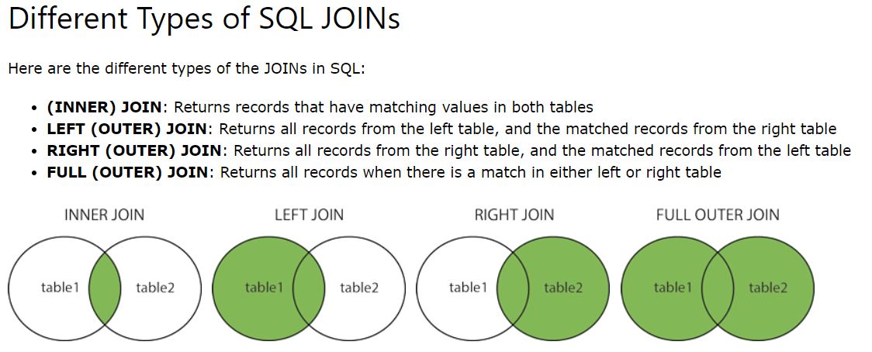

<https://datasciencebeginners.com/2018/12/09/12-merging-tables-in-r/>

<http://www.datasciencemadesimple.com/join-in-r-merge-in-r/>